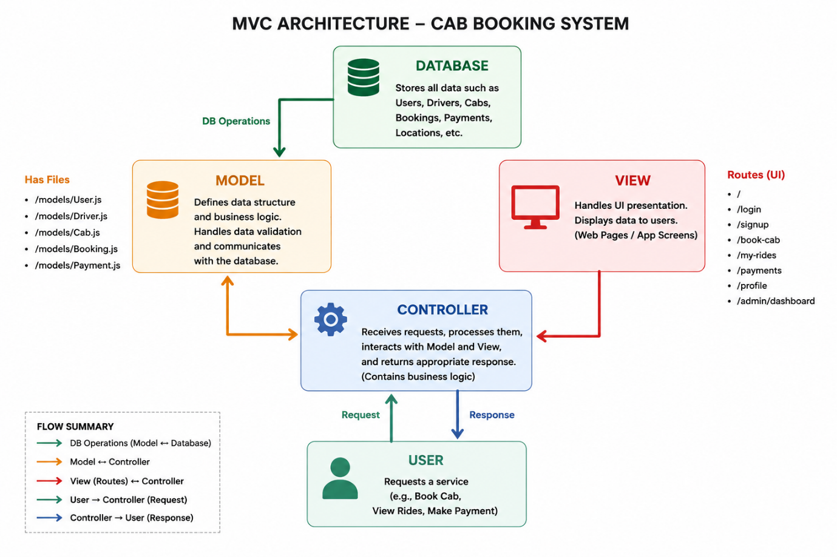
MVC Architecture – Ucab Cab Booking System
The Ucab Cab Booking System is developed using the Model-View-Controller (MVC) architecture. This design pattern separates the application into three independent layers, making the system organized, maintainable, and easy to scale.

Model Layer (Data Layer)
The Model layer manages the application's data and business rules. It defines the database schemas and performs CRUD operations using Mongoose with MongoDB.
The main models include:
- User Model
- Driver Model
- Cab Model
- Booking Model
- Payment Model
These models store and manage user accounts, driver information, cab details, ride bookings, and payment records.

Controller Layer
The Controller layer processes client requests and connects the View with the Model.
It performs tasks such as:
- User and Driver Authentication
- Cab Booking Management
- Fare Calculation
- Ride Tracking
- Payment Processing
- Booking History Management
- Admin Operations
After processing the request, the controller sends the appropriate response back to the user.

View Layer (Routing Layer)
The View layer represents the application's user interface and API routes. It handles HTTP requests (GET, POST, PUT, DELETE) and forwards them to the appropriate controller.
Typical routes include:
- User Registration & Login
- Driver Registration & Login
- Cab Booking
- Ride Tracking
- Online Payment
- Booking History
- Admin Dashboard
This layer enables smooth interaction between users and the application.

Advantages of Using MVC in Ucab
Separation of Concerns
Each layer has a specific responsibility, making the code organized and easier to maintain.
Scalability
New features such as ride sharing, GPS navigation, or promotional offers can be added without affecting the existing code.
Reusability
Controllers and models can be reused across different modules, reducing code duplication.
Easy Testing
Each component can be tested independently, improving application reliability and simplifying debugging.
Team Collaboration
Frontend, backend, and database developers can work on different layers simultaneously, increasing development efficiency.

